PYTHON
Chap 1 : Python
- Installation, Configuration, IDLE, Manual, Visual Code, Print

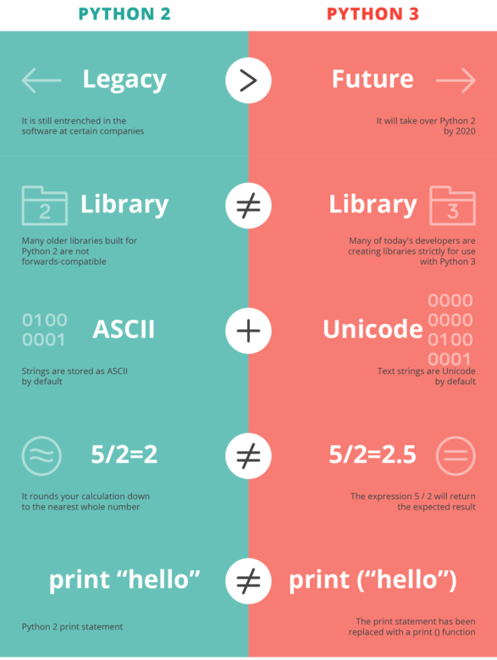
- Git, GitHub and Your Repo
Overview
Github is a place you can store, demonstrate and collaborate with other developers on your code or others. You can hold your own code there (which is what we'll be doing today) as well as copy other people's code and build off of it in your own personal projects!
- Git is a version control and source code management system that developers use to manage and store their code.
- Git allows a code base to be updated by multiple people in a safe manner that will not affect the end users experience.
- It gives us a way to develop and fix code in development branches and then merge it into a stable and safe branch.
- Git is how real world development occurs and it is also how you will turn in assignments.
Git and GitHub Setup
- Create a GiHub account
- Understand how git is used and learn to use it for this course.
- Set up your coding environment in your text editor, VS Code.
- Understand and use git & gitHub in this course and for your career.

Pre-Windows 10 Machines
- Download Git and gitBash
- Open gitBash

Getting your Python Repo
- Make a copy of the Python workbook by navigating to https://github.com/angomablaise/python
- Click fork in upper-right hand corner
- Go to your copy of the workbook https://github.com/
- Click the green clone or download button
- Cloning the repo to your local computer
- git clone https://github.com/angomablaise/python.git
- inside python folder through the terminal , type:
- git remote add upstream https://github.com/angomablaise/python.git
- current git commands
  - git branch
  - git status
  - git checkout branch-name
  - git add .
  - Git commit -m “comment ”
  - Git push
  - Git pull
  - Git merge

…or create a new repository on the command line
echo "# python" >> README.md
git init
git add README.md
git commit -m "first commit"
git remote add origin https://github.com/angomablaise/python.git
git push -u origin master

…or push an existing repository from the command line
git remote add origin https://github.com/angomablaise/python.git
git push -u origin master

…or import code from another repository
You can initialize this repository with code from a Subversion, Mercurial, or TFS project.
Tips

- Always know where you are and what changes you have made. Do git status and git branch regularly.
- Commit and push early and often.
- You will learn git by doing git. Don't be afraid to mess up, we can revert anything.
- When you are first doing these steps, have them out and follow them. Don't worry about memorizing them, it will happen naturally and in no time.
- Remember, before you make a new branch, go to master branch first.

Chapter 2: Input, Processing, Output
- Variable, assignment,
- Operator, compute
- Print, Input
- Type : str, float, int
print('Nudge nudge')
print('Wink wink')
print('Know what I mean?')
print("Don't fear!")
print("I'm here!")
print('Your assignment is to read "Hamlet" by tomorrow.')
print("""I'm reading "Hamlet" tonight.""")
print("""One
Two
Three""")
# Get the user's name, age, and income.
name = input('What is your name? ')
age = int(input('What is your age? '))
income = float(input('What is your income? '))
# Display the data.
print('Here is the data you entered:')
print('Name:', name)
print('Age:', age)
print('Income:', income)
Exercices
1. Write a statement that displays your name.
2. Write a statement that displays the following text:
Python's the best!
3. Write a statement that displays the following text:
The cat said "meow."
1. Write Python code that prompts the user to enter his or her height and assigns the user’s
input to a variable named height.
2. Write Python code that prompts the user to enter his or her favorite color and assigns
the user’s input to a variable named color.
3. Write assignment statements that perform the following operations with the
variables a, b, and c.
a. Adds 2 to a and assigns the result to b
b. Multiplies b times 4 and assigns the result to a
c. Divides a by 3.14 and assigns the result to b
d. Subtracts 8 from b and assigns the result to a
4. Assume the variables result, w, x, y, and z are all integers, and that w = 5, x = 4,
y = 8, and z = 2. What value will be stored in result after each of the
following statements execute?
a. result = x + y
b. result = z * 2
c. result = y / x
d. result = y – z
e. result = w // z
5. Write a Python statement that assigns the sum of 10 and 14 to the variable total.
6. Write a Python statement that subtracts the variable down_payment from the variable total and assigns the result to the variable due.
7. Write a Python statement that multiplies the variable subtotal by 0.15 and assigns the
result to the variable total.
8. What would the following display?
a = 5
b = 2
c = 3
result = a + b * c
print(result)
9. What will the following statement display?
print('George', 'John', 'Paul', 'Ringo', sep='@')

Programming Exercises
1. Personal Information
Write a program that displays the following information:
• Your name
• Your address, with city, state, and ZIP
• Your telephone number
• Your college major
2. Sales Prediction
A company has determined that its annual profit is typically 23 percent of total sales. Write
a program that asks the user to enter the projected amount of total sales, and then displays
the profit that will be made from that amount.
Hint: use the value 0.23 to represent 23 percent.
3. Land Calculation
One acre of land is equivalent to 43,560 square feet. Write a program that asks the user to
enter the total square feet in a tract of land and calculates the number of acres in the tract.
Hint: divide the amount entered by 43,560 to get the number of acres.
4. Total Purchase
A customer in a store is purchasing five items. Write a program that asks for the price of
each item, and then displays the subtotal of the sale, the amount of sales tax, and the total.
Assume the sales tax is 6 percent.
5. Distance Traveled
Assuming there are no accidents or delays, the distance that a car travels down the interstate can be calculated with the following formula:
Distance = Speed X Time
A car is traveling at 60 miles per hour. Write a program that displays the following:
• The distance the car will travel in 5 hours
• The distance the car will travel in 8 hours
• The distance the car will travel in 12 hours
6. Sales Tax
Write a program that will ask the user to enter the amount of a purchase. The program should then compute the state and county sales tax. Assume the state sales tax is 4 percent and the county sales tax is 2 percent. The program should display the amount of the purchase, the state sales tax, the county sales tax, the total sales tax, and the total of the sale (which is the sum of the amount of purchase plus the total sales tax).
Hint: use the value 0.02 to represent 2 percent, and 0.04 to represent 4 percent.
7. Miles-per-Gallon
A car’s miles-per-gallon (MPG) can be calculated with the following formula:
MPG = Miles driven / Gallons of gas used
Write a program that asks the user for the number of miles driven and the gallons of gas used. It should calculate the car’s MPG and display the result.
8. Tip, Tax, and Total
Write a program that calculates the total amount of a meal purchased at a restaurant. The program should ask the user to enter the charge for the food, and then calculate the amount of a 15 percent tip and 7 percent sales tax. Display each of these amounts and the total.
9. Celsius to Fahrenheit Temperature Converter
Write a program that converts Celsius temperatures to Fahrenheit temperatures. The formula is as follows:
F=(9/5)*C + 32
The program should ask the user to enter a temperature in Celsius, and then display the
temperature converted to Fahrenheit.
10. Stock Transaction Program
Last month Joe purchased some stock in Acme Software, Inc. Here are the details of the purchase:
• The number of shares that Joe purchased was 1,000.
• When Joe purchased the stock, he paid $32.87 per share.
• Joe paid his stockbroker a commission that amounted to 2 percent of the amount he paid for the stock.
Two weeks later Joe sold the stock. Here are the details of the sale:
• The number of shares that Joe sold was 1,000.
• He sold the stock for $33.92 per share.
• He paid his stockbroker another commission that amounted to 2 percent of the amount
he received for the stock.
Write a program that displays the following information:
• The amount of money Joe paid for the stock.
• The amount of commission Joe paid his broker when he bought the stock.
• The amount that Joe sold the stock for.
• The amount of commission Joe paid his broker when he sold the stock.
• Display the amount of money that Joe had left when he sold the stock and paid his
broker (both times). If this amount is positive, then Joe made a profit. If the amount is
negative, then Joe lost money

